A field Identification Guide to

INVASIVE PLANTS

Within the Northern Metalmark Butterfly Conservation area
By: Beau Martinez

By: Beau Martinez and Geordie Elkins

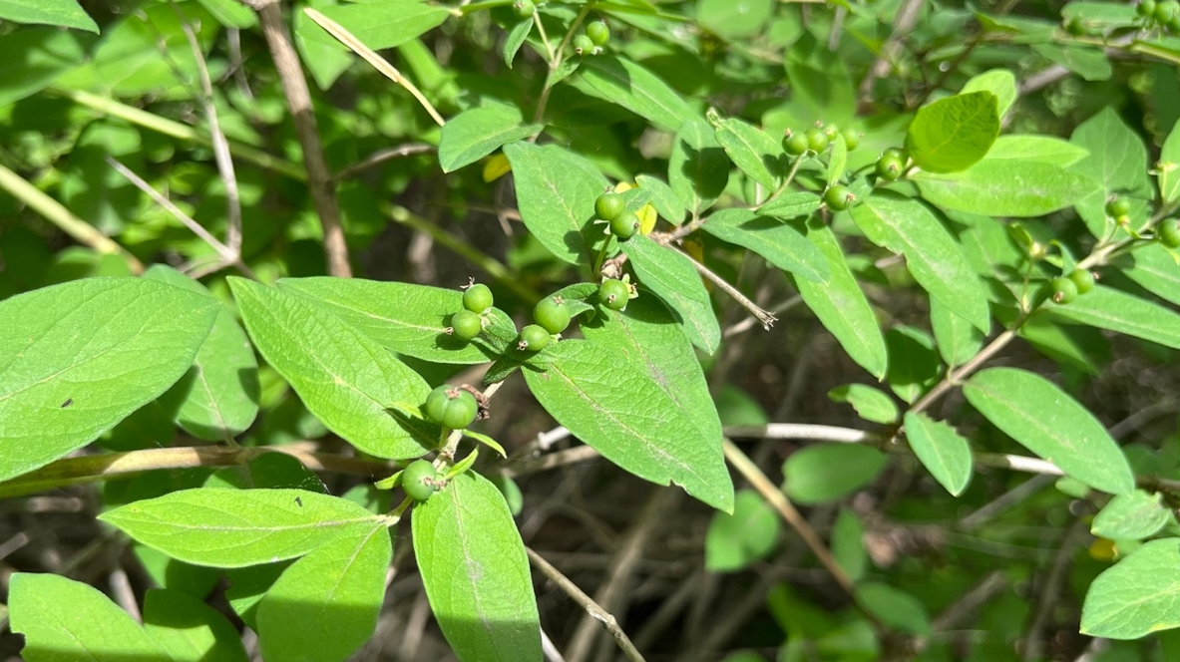

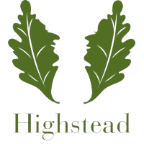

PLANT IDENTIFICATION KEY

TABLE OF CONTENTS

Identification key…………………………………………………………….…..2
Herbs
Coltsfoot…………………………...….…………………………………………..3
Purple Loosestrife…………………….…………………………………...……..4
Queen Anne’s Lace……………………..……………………………...………5
Black and Pale Swallowworts……………………………………………...….6
Grass-like Plants
Common Reed…………………………………………………………..………7
Shrubs and Woody Vines
Asian Bittersweet…………………………………………………..………...…..8
Autumn Olive………………………………………………………….....………9
Burning Bush……………………………………………………………………..10
False Buckthorn………………………………………………..………..………11
Common Privet…………………………………………………………….…..12
Shrub Honeysuckle……………………………………………………….……13
Linden Viburnum……………………………………………………………….14
Extra Information
Cutting Schedule…………………………...………………………………….15
Work Cited………………………………………………………………………16

IDENTIFICATION KEY

LEAF FORMATIONS

OPPOSITE ALTERNATE WHORLED BASAL COMBINED

LEAF BASES
LEAF-STEM CONNECTION

OBTUSE CORDATE ACUTE
CONNECTED WITH STEM

LEAF TYPES

TOOTHED
ENTIRE
LOBED AT BOTTON

COLTS FOOT
Tussilago farfara

IDENTIFICATION

- Alternate, toothed and cordate basal leaves
- Bottom of the leaf is covered with white, wool-like hair.
- Top of the leaf is smooth and waxy in appearance
- Basal leaves usually grow 2-10 in. long.
- Bright yellow and dandelion-like flowers appear in early spring and start dying soon before the leaves show
- Average total height is between 5-7 in.

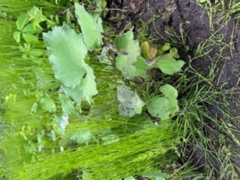

MECHANICAL CONTROL

The best method for controlling Coltsfoot is hand pulling, especially when the soil is damp. Small pieces of roots left behind can grow back, so it is vital to pull all the plant out.

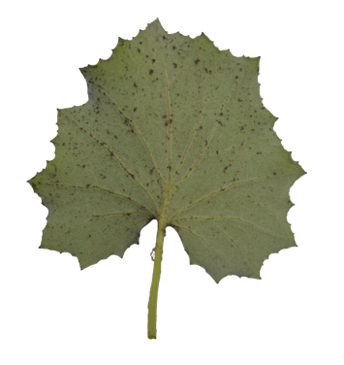
FLOWERING DATES
February to April
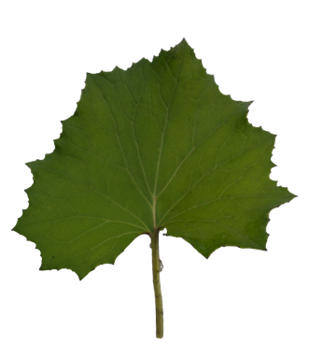
Back of leaf
FRUITING DATES
April to May

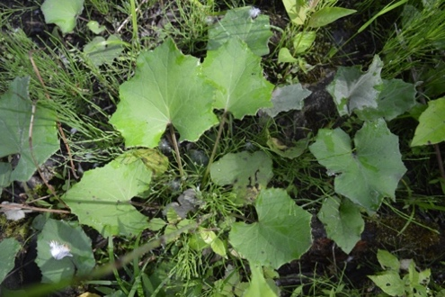

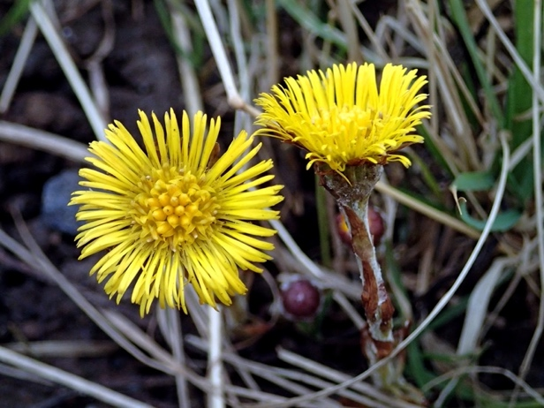

Front of leaf
Photo: Grey Granite 2013

PURPLE LOOSESTRIFE
Lythrum salicaria

IDENTIFICATION

- Grows up to 5 feet in height.
- Opposite or whorled leaves are dark-green, lance-shaped, and connected to the stem. They are 1.5 to 4 in. long and obtuse or cordate at the base.
- Square-shaped stem, generally 4 to 6 sided
- Purplish flowers, surrounding small yellow centers, develop in 4-16 in long spikes at the top of the stems
- Has thick and woody roots. On mature plants, roots are extensive and can send out 30 to 50 shoots.
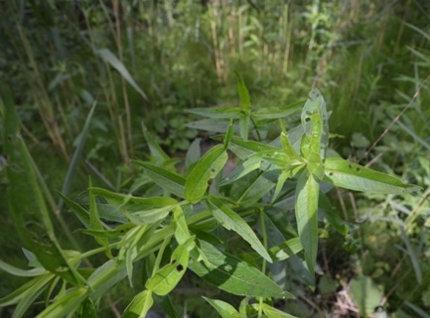

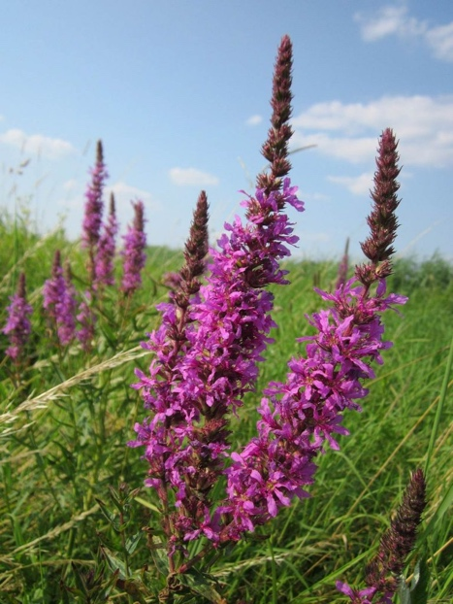
Note: Image above shows damage from loosestrife beetles, which are orangish-brown and have dark bands along the wing margins. These insects are bio-controls, which means they reduce Purple loosestrife populations.
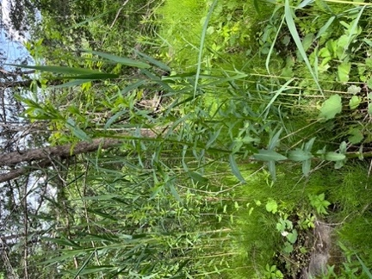

FLOWERING DATES
July to September

FRUITING DATES
August to September

Photo: live-native.com
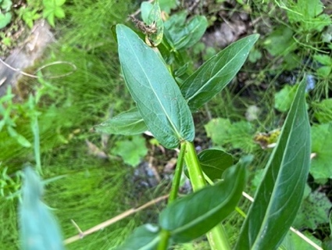
MECHANICAL CONTROL

Hand-pulling is optimal for small populations. This is easiest if done when plants are young and small (up to 2 years). Removing flower spikes (purple flowers) will prevent seeds from growing into more plants. Cut the stems at the ground to inhibit growth.

QUEEN ANNE’S LACE
Daucus carota

IDENTIFICATION

- Flowers have a flat-topped cluster of small white flowers (umbels). They sometimes have a solitary purple flower in the center
- The bases of leafstalks are broad and flat.
- Leaves are deeply lobed and toothed, have acute bases, and are arranged oppositely
- Stems are straight with vertical veins and fine hairs running along them
- Usually grow an average of 1 meter, or 3 feet.
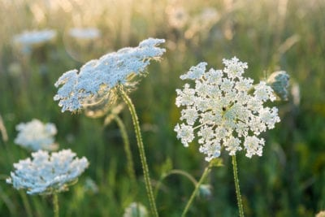

Photo: Gardening Know How

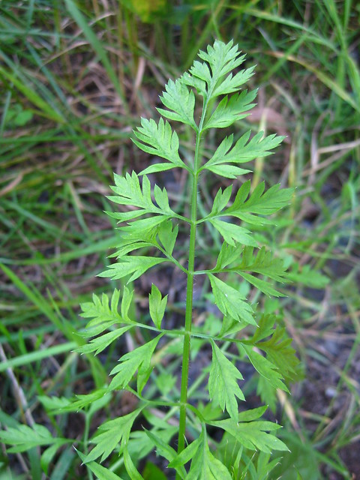
MECHANICAL CONTROL

Hand-pull plants before they flower if possible. Try to remove the roots as well, as they can grow back if left in the soil. Till or dig the soil regularly to prevent young sprouts from taking roots.

FLOWERING DATES
Late Spring to Mid Fall
FRUITING DATES
May and June

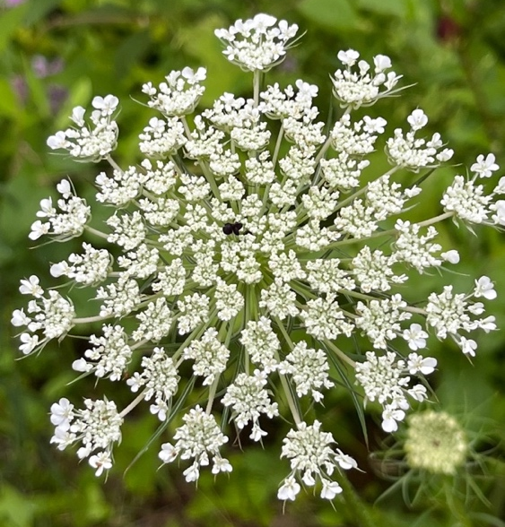

Photo: Virens (Latin for Greeting)

A single dark flower in the very center
Photo: GoBotany

BLACK AND PALE SWALLOWWORTS
Cynanchum louiseae & Cynanchum rossicum

IDENTIFICATION

- Identified as a vine
- Leaves are entire, large, shiny, dark green, and opposite. They are cordate at the base.
- Seeds are enclosed in slender, light-green pods
- The pods turn brown and split later in the season when they matured
- Both have flowers are small and star-shaped and can range from pink and reddish brown to dark purple and black depending on the specific species
- Black swallowworts grow from rhizomes, the thick base stem that all roots grow out of.

MECHANICAL CONTROL

Plants should be dug up manually through either hand-pulling or shoveling. When the pods have opened and seeds have begun to disperse, it is best to stay out of the area to prevent spreading the seeds further.

FLOWERING DATES
June and July

FRUITING DATES
July to September

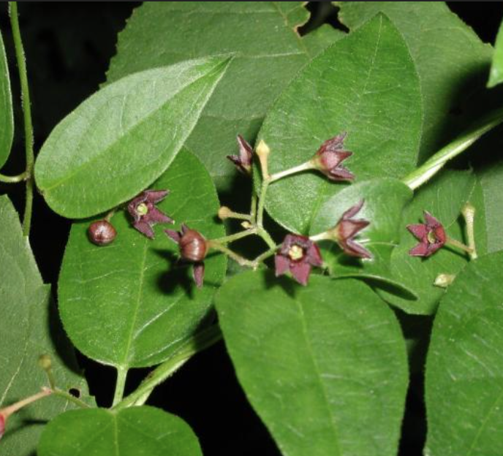
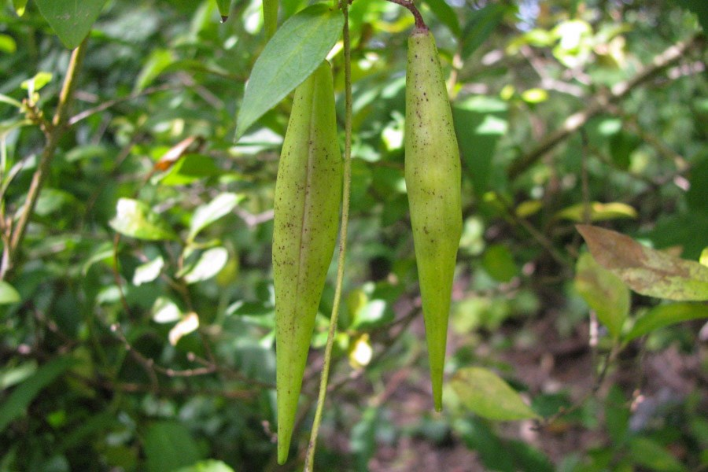

Photo: Leslie J. Mehrhoff 2008
Photo: Vermont Invasives
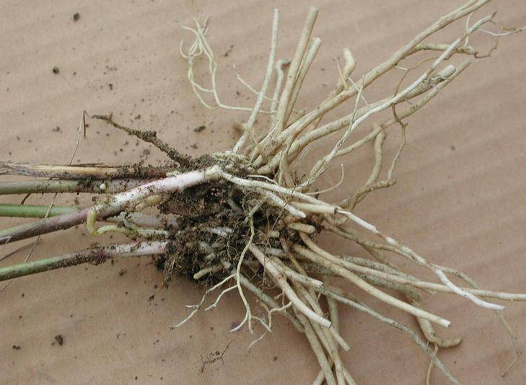
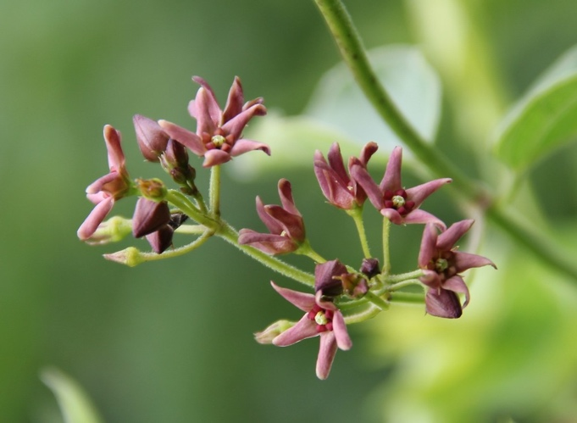

Image of Black Swallowwort Rhizomes
Photo: Gobotany
Photo: Leslie J. Mehrhoff 2006

COMMON REED
Phragmites australis

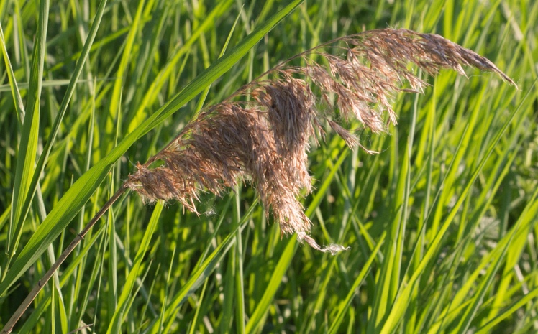
IDENTIFICATION

- Grows up to 12 feet in height
- Long, lance-shaped, gray-green leaves connected to the branch
- Purple-brown plume-like flowers
- The seeds are brown, light weight, and about 0.3 in. long
- Stalks and plumes turn tan in the fall and remain throughout the winter

Photo: Tomas Leibelt
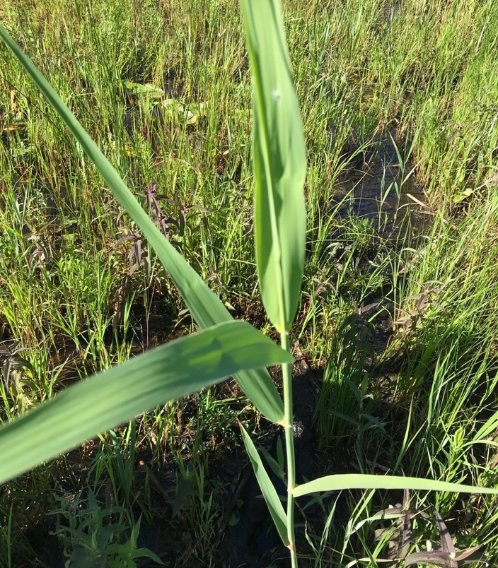
MECHANICAL CONTROL

Common reed stems should be cut below the lowest leaf, leaving a 6” or shorter stump. Cut or pulled reeds must be removed from the site. Best cutting dates occur in late July. Make sure the plants are dead before placing them in mulch or compost pile. Either dry them out or place in heave duty plastic bags.

Regular cutting and thatch removal weakens colonies and allows native plants to coexist with Phragmites where eradication is not possible.

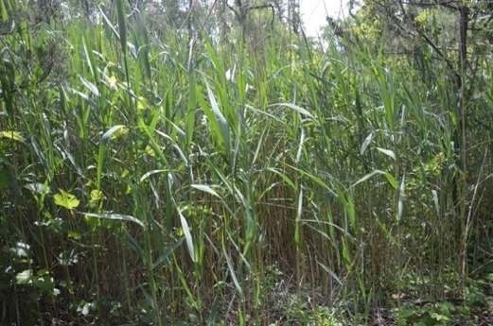
FLOWERING DATES

July to September

FRUITING DATES
July to November
Common reeds at the conservation site

ASIAN BITTERSWEET
Celastrus orbiculatus

IDENTIFICATION

- Woody twining vine
- Alternately arranged leaves that are finely toothed and glossy that spiral evenly around the stem
- Fruits have a conspicuous yellow casing that opens to reveal a bright red fleshy interior
- Roots are orange colored
- Cut or pulled or weed whacked
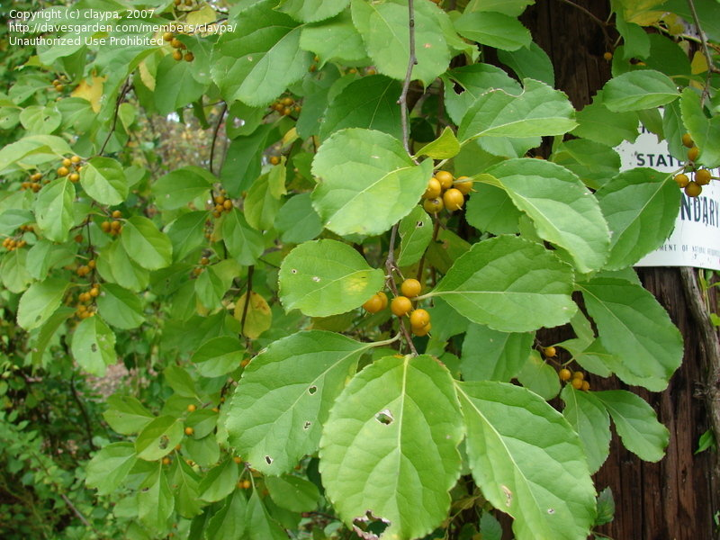

MECHANICAL CONTROL

Pull small plants, including the entire root system. Cut larger vines close to the ground every couple of weeks to prevent resprouting and to deplete the root system.
It is recommended to weed whack in the wintertime, Note where the plants are in the spring and summer because of the indistinguishable branches without leaves in the winter.

Photo: davesgarden.com

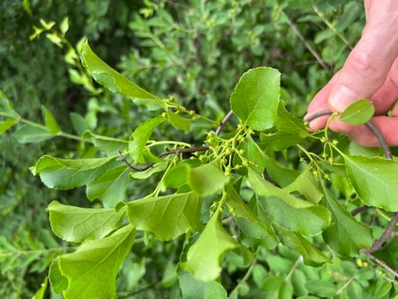

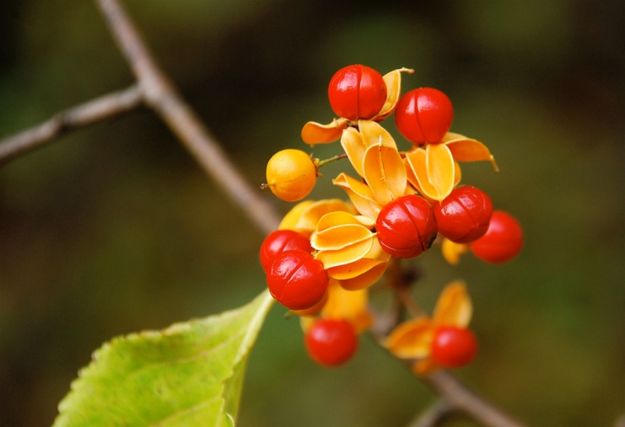

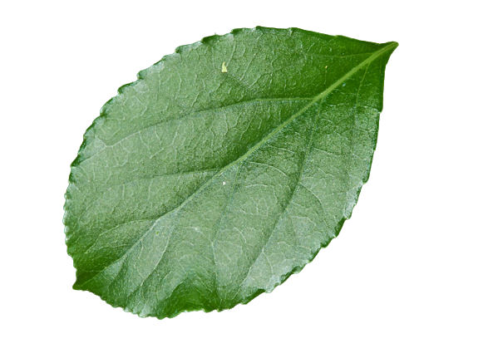
Asian Bittersweet at the site

Photo: thespruce.com
FLOWERING DATES
May to early June

FRUITING DATES
Late Summer to Early Fall

Front of leaf

AUTUMN OLIVE
Elaeagnus umbellata

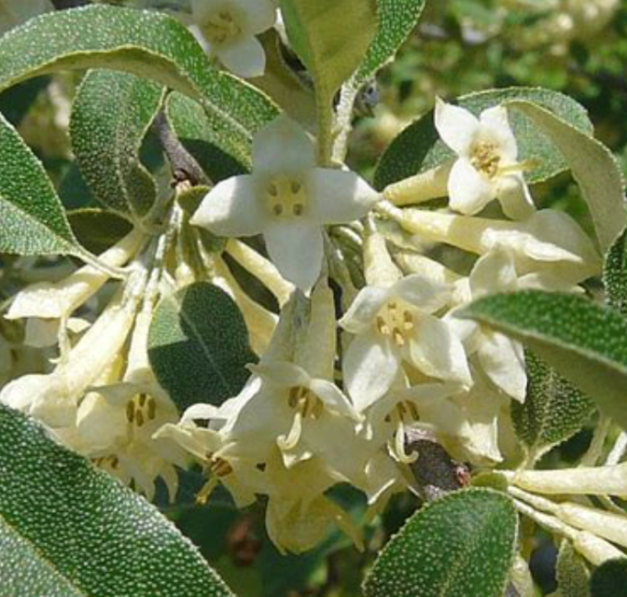
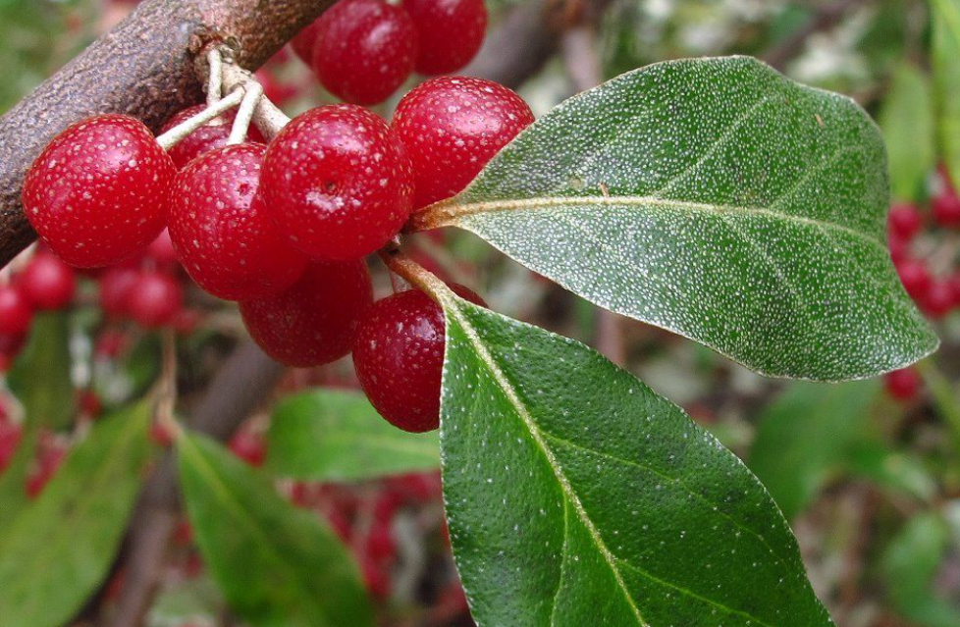

Photo: Toronto Wildlife
Photo: Katie Meyers
Proven Winners
IDENTIFICATION

- Large shrub or small tree form, 15-20’ tall
- Leaves are alternate, oval and dark gray or green in color with silvery scales underneath. They have an acute base and are smooth.
- Silver-brown stems covered with numerous brown lenticels Light gray bark
- Flowers are creamy to light yellow in color and fragrant
- Fruit color is brown and then turns to dark red with small silver dots

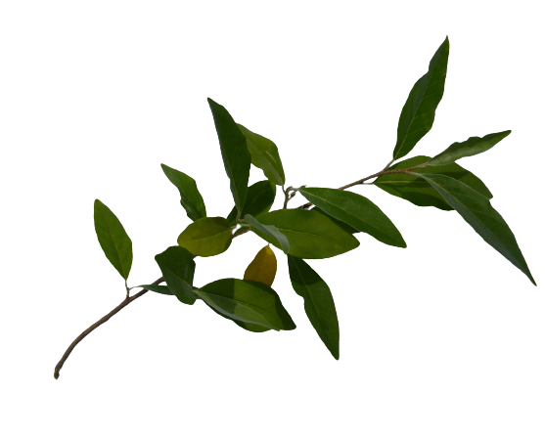
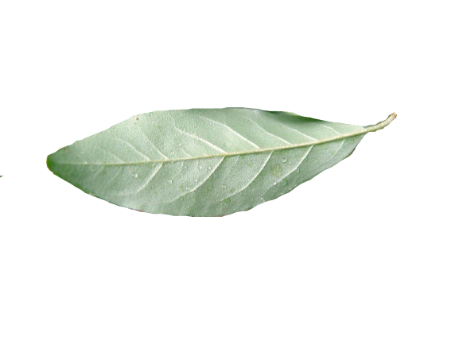
Note: In the wintertime, to identify autumn olive, look for the speckled dots on the branches as seen in the above image
MECHANICAL CONTROL

Autumn Olives with small diameters can be removed with a small weed wrench when soils are moist. In certain situations, larger trees can be removed using a tractor/chain or root brute. The remaining exposed roots should be cut off below ground level and buried.

FLOWERING DATES
April to May

FRUITING DATES
September to November
Back of leaf

BURNING BUSH
Euonymus alatus

IDENTIFICATION

- Leaves are oval to tear-drop shaped, finely toothed, entire, opposite, oval to tear-drop shaped finely toothed leaves
- Large shrub, 5 to 10 feet tall.
- Corky, wing-like rides on stems
- Opposite, oval to tear-drop shaped finely toothed leaves
- Bright red fall foliage
- Showy red-purple fruits split open to reveal bright red-orange fleshy seeds
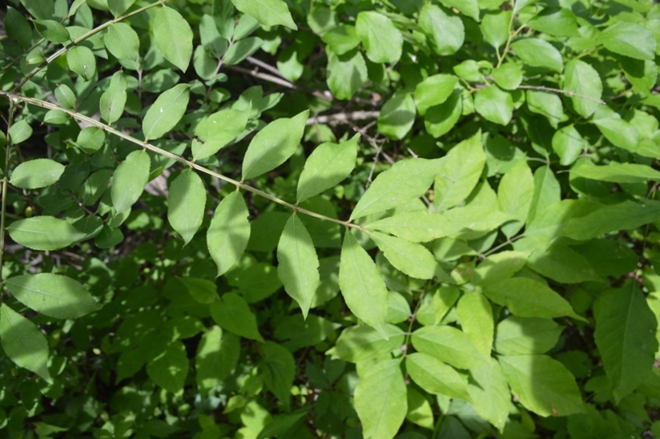

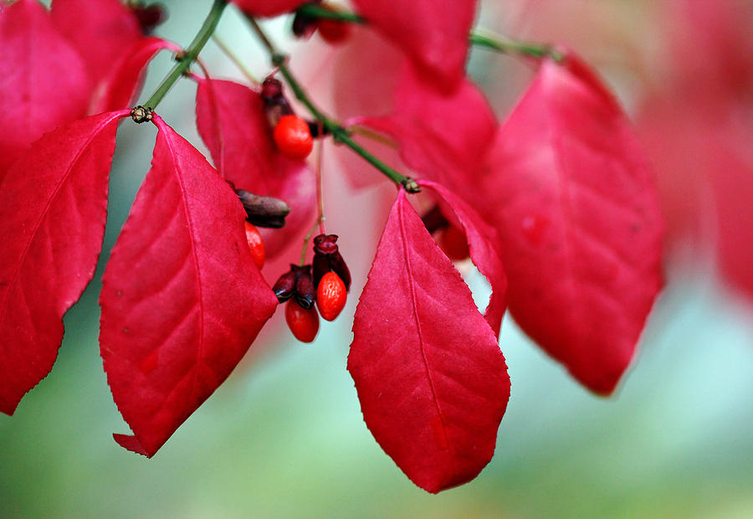
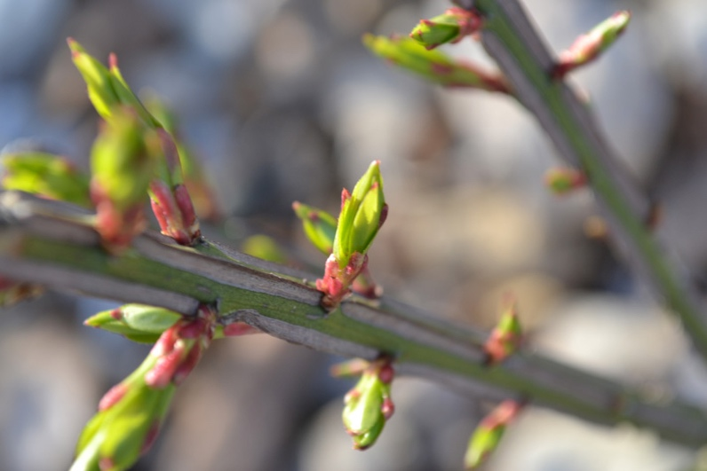

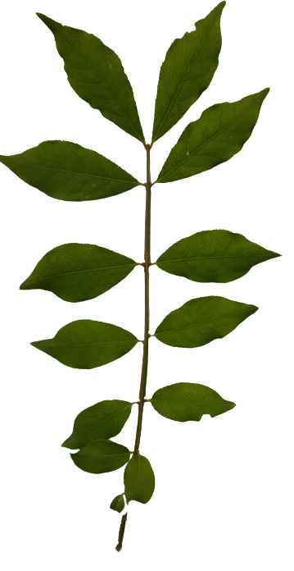
Photo: Debbie Oppermann, 2016
Bush leaves in the fall
Photo: Clean Cut Property
Flower buds and close-up of the winged branches
MECHANICAL CONTROL

Pull or dig young plants, making sure to remove the entire root. Large plants can be cut at ground level but will resprout from the base, so repeated cutting is necessary

It is advised to during the winter months to avoid as much spring growth as possible

FLOWERING DATES
May to June
FRUITING DATES
August to January

FALSE BUCKTHORN
Frangula alnus

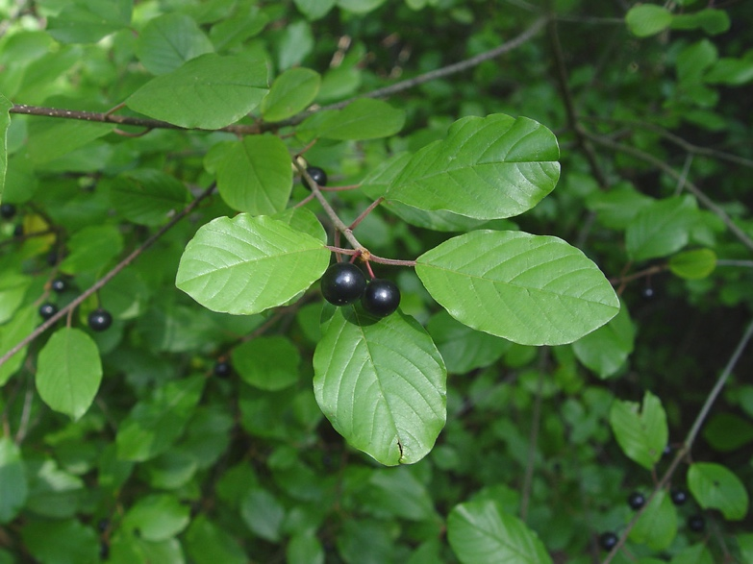
IDENTIFICATION

- Leaves are arranged alternatively, entire, and have an obtuse base. They also appear waxy and have defined pinnate veins
- Flowers are small and star-shaped with five greenish-white triangular petals.
- Flowers appear in clusters in the leaf axils.
- Flowers also develop into small red berries in late summer and dark purple berries in early fall.

Photo: Donald Cameron, 2022
MECHANICAL CONTROL

Small plants may be hand-pulled. Larger plants can be dug or pulled using a leverage tool such as a weed wrench.

FLOWERING DATES
May and June

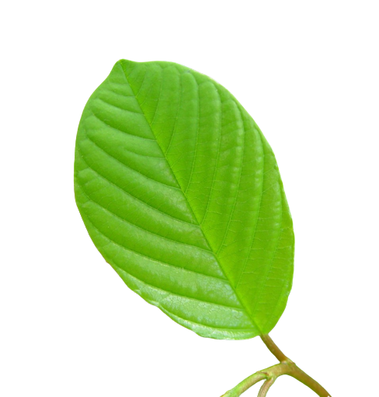
FRUITING DATES
Late summer to early fall
Flower bud in Early June

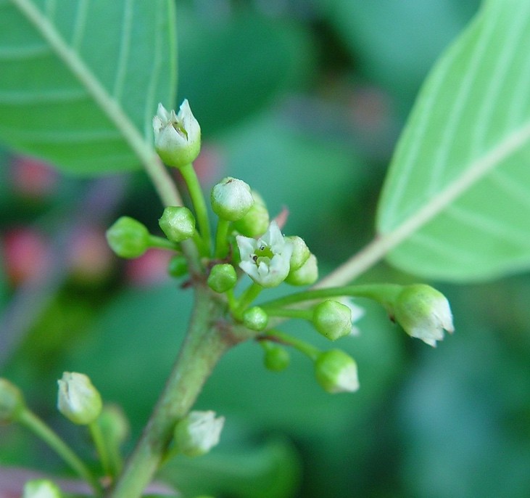

Photo: Heines, 2022
Photo: Heines, 2022

COMMON PRIVET
Ligustrum vulgare

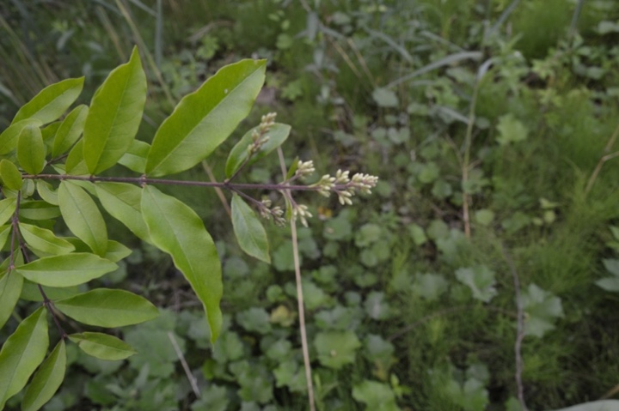
IDENTIFICATION

- Leaves are entire, dark green, about 2.5 in. long and are oppositely arranged. The bottom of leaves are acutely shaped
- They are connected to the branches by tiny stems
- Flowers are small and white and are usually seen in small clusters. Each flower has four petals
- Berries are small, and glossy and ripen to black in the fall

Photo of flower buds on the site from early June

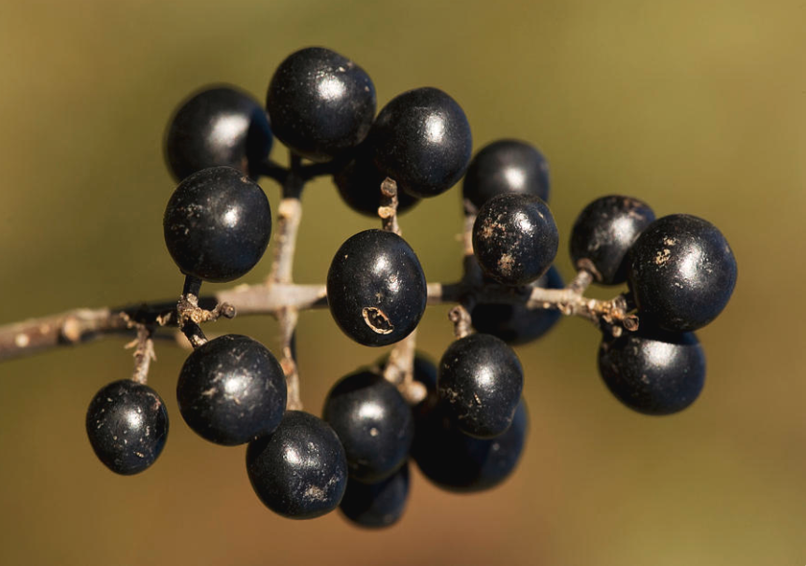
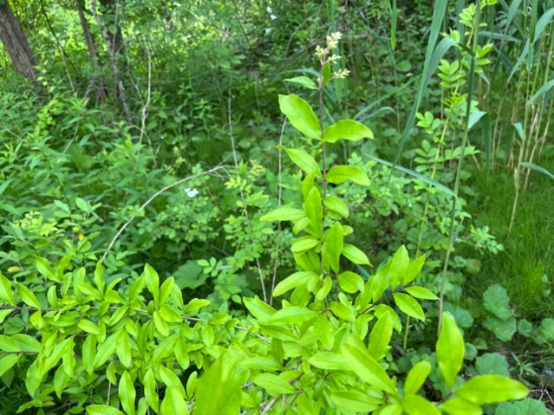

Photo: Gibbons, 2018
Proven Winners
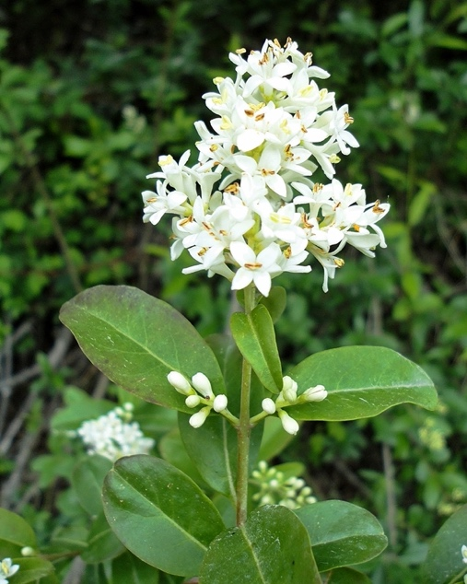
MECHANICAL CONTROL

Individual small plants can be pulled by hand. Be sure to remove all of the root as well.

FLOWERING DATES
April to July

Photo: Plantys
FRUITING DATES
May and June

SHRUB HONEYSUCKLE
Lonicera sp.

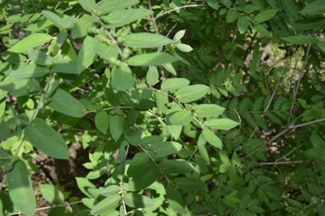
IDENTIFICATION

- Leaves are 2-3 inches long, and are entire, smooth, arranged oppositely, and have acute bases
- The grayish-brown bark is distinctly striated, or vertically shredded in appearance, which is especially noticeable on large stems
- In midsummer, red, orange, or pinkish round and shiny berries emerge ingroups of four near the stem

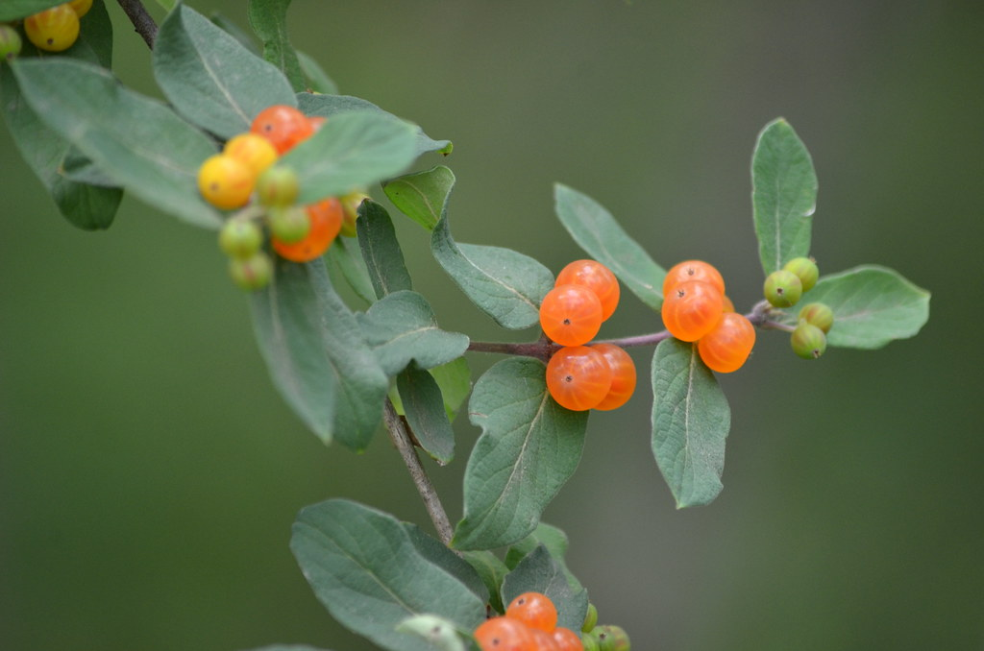

MECHANICAL CONTROL

Small infestations can be easily pulled by hand. Larger stems can be removed with lever-type wrenching tools, hoes, or even chainsaws. Cut to the ground.

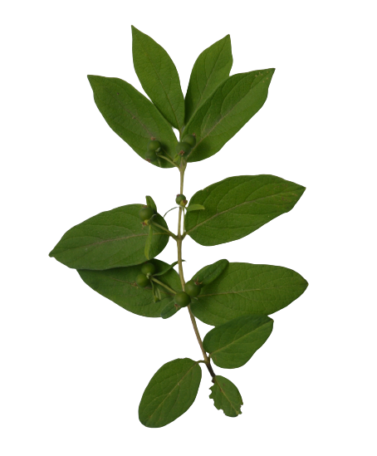

Photo: Helen F.

Lonicera tatarica
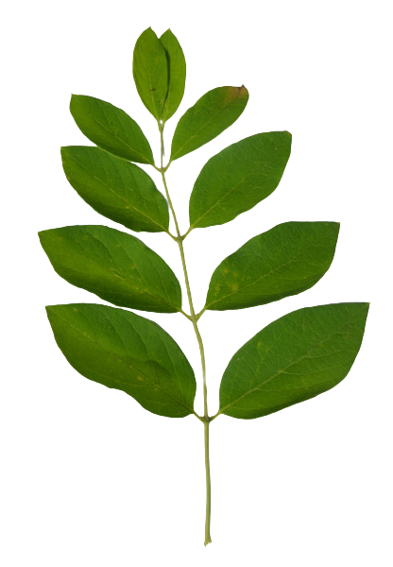
FLOWERING DATES
May and June
FRUITING DATES
July and August

Lonicera hirsuta
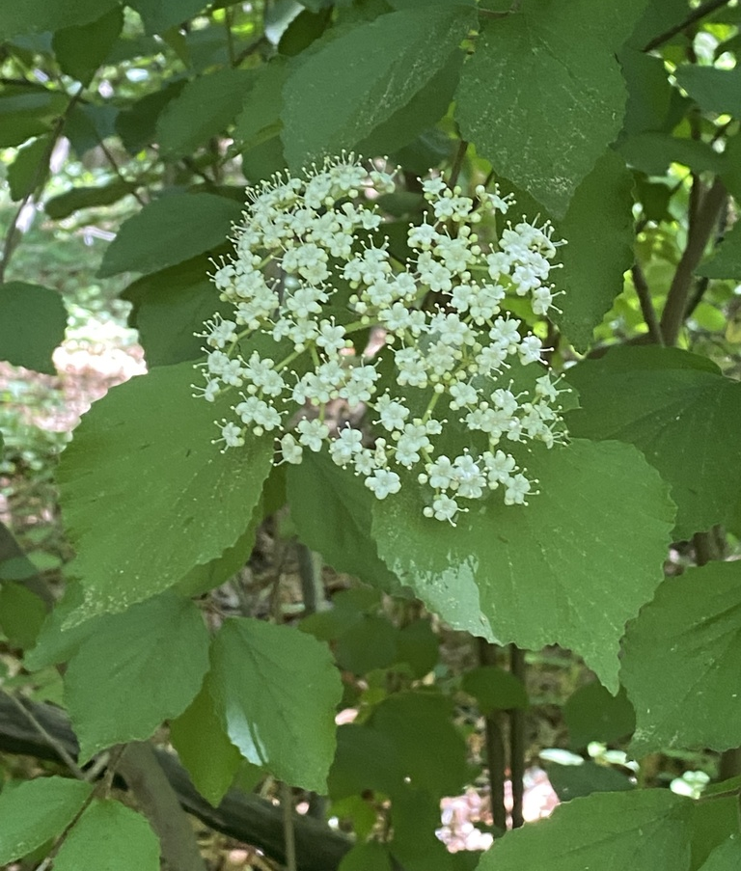
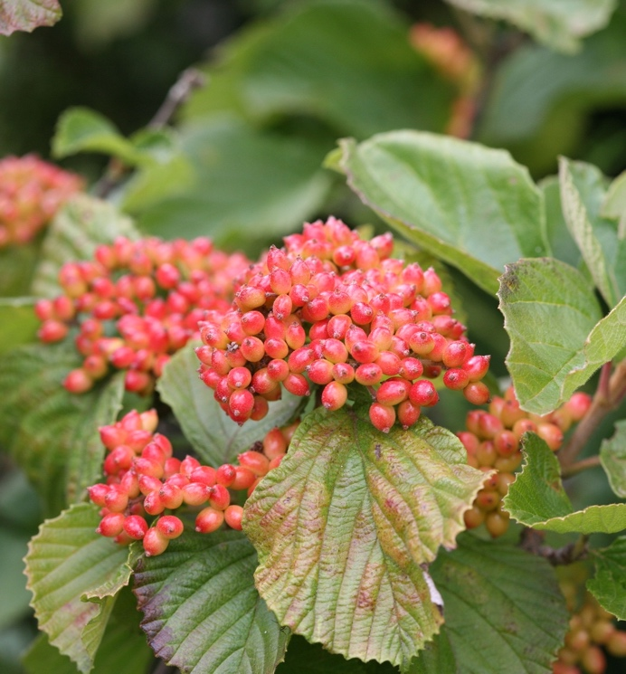
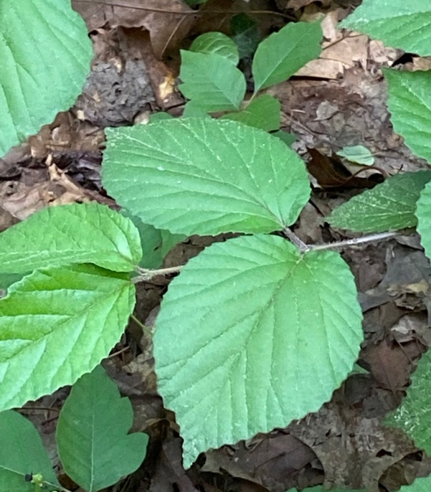
Photo: iNaturalist
Photo: iNaturalist 2022
Photo: Natorp’s
FRUITING DATES
September to December
FLOWERING DATES
May to June
IDENTIFICATION

- Leaves are simple, slightly toothed and oppositely arranged, and the shape can range from obtuse to acute
- Leaf has soft pubescence.
- Leaf size can range from 2-5 in. long
- White flowers that grow in small clusters, and have long threads that stick out
- Fruits are red and fleshy, and grow in tight clusters
MECHANICAL CONTROL

Even through flowering times for Linden Viburnums start in May, cutting should be avoided in spring because cut branches can still reproduce. However, seedlings can and should be pulled by hand and seed heads should be removed from mature plants to prevent seed dispersal and seeding from May to early June.

LINDEN VIBURNUM
Viburnum dilatatum
EARLY SPRING (MARCH to APRIL)

Coltsfoot – cut off spent flowers to prevent them from going to seed.
Autumn Olive – pull small plants and cut larger plants next to the ground.
Burning Bush – pull or cut to the ground before fruit forms.

LATE SPRING (LATE MAY or EARLY JUNE)

Coltsfoot – Hand pull if ground is moist and you can pull out the roots. Otherwise, cut back leaves to reduce competition and weaken the plant.
Queen Anne’s Lace – I am not sure if you can pull this. The best way to control is to cut off flowers before it goes to seed.
Common Privet – Pull or cut to the ground before fruit forms.
Shrub Honeysuckle – pull or cut to the ground before fruit forms.
False Buckthorn – pull or cut to the ground before fruit forms.
Swallowwort – Pull Stems making sure to get clusters of buds just below soil surface.

MID SUMMER (LATE JULY or EARLY AUGUST)

Purple Loosestrife – pull or cut off flowers before it goes to seed.
Common Reed – cut to the ground before going to flower and seed.
Swallowwort – Look for any regrowing or missed stems and remove seed pods

WINTER (DECEMBER to FEBRUARY)

Common Reed – cut to ground and remove thatch.
Asian Bittersweet - weed whack or cut dry stalks to prevent growth.
Autumn Olive - weed whack or cut dry stalks to prevent growth.

MANAGEMENT TIMELINE
WORK CITED

“Swallowwort, Black or Pale.” New York Invasive Species Information, 5 June 2019, https://nyis.info/Invasive_sp ecies/swallow-wort/.
“Swallow-Worts.” Cornell Cooperative Extension, 2019, http://ccetompkins.org/environment/invasive-nuisance-species/invasive-plants/swallow-worts.
“Wildflowers of the Adirondacks: Coltsfoot (Tussilago Farfara).” Coltsfoot | Tussilago Farfara, https://www.wildadirondacks.org/adirondack-wildflowers-coltsfoot-tussilago-farfara.html.
Russell, Matt. “Controlling Buckthorn: The Who, What, Where When and How.” UMN Extension, 29 July 2021, https://extension.umn.edu/natural-resources-news/controlling-buckthorn.
“Autumn Olive Elaeagnus Umbellata.” EdibleWildFood, https://www.ediblewildfood.com/ autumn-olive.aspx.
“Vermont Invasives.” Burning Bush or Winged Euonymus | Vermont Invasives, https://vtinvasives.org/inv asive/burning-bush-or-winged-euonymus.
David R. Jackson Extension Educator, et al. “Oriental Bittersweet.” Penn State Extension, 30 May 2022, https://extension.psu.edu/oriental-bittersweet.
“Phragmites (Common Reed).” SOM - State of Michigan, https://www.michigan.gov/invasives/idreport/plants/ grass/phragmites-common-reed.
Tilley, D.J., and L. St. John. 2012. Plant Guide for common reed (Phragmites australis). USDA-Natural Resources Conservation Service, Aberdeen, ID Plant Materials Center. 83210-0296.
“Queen Anne's Lace Daucus Carota.” EdibleWildFood, https://www.ediblewildfood.com/queen-annes-lace.aspx.
“Exotic Species: Purple Loosestrife (U.S. National Park Service).” National Parks Service, U.S. Department of the Interior, https://www.nps.gov/articles/purple-loosestrife.htm.
David R. Jackson Extension Educator, et al. “Shrub Honeysuckles.” Penn State Extension, 6 June 2022, https://extension.psu.edu/shrub-honeysuckles.
Photos:
“Autumn Olive: Fruit.” Toronto Wildlife, May 2010. http://www.toronto-wildlife.com/Trees/Oleaster_family/more_ autumn_olive.html.
Cameron, Donald. “Fruits: Frangula alnus.” Go Botany, 2022, https://gobotany.nativeplanttrust.org/species/fran gula/alnus/.
“Coltsfoot: Tussialgo farfara.” Grey Granite Blog Spot, 16 Feb. 2013. http://greygraniteblogspot.blogspot.com /2013/02/coltsfoot.html.
Conrad, Mareike. “Flowers: Cynanchum rossicum.” Go Botany, 2022. https://gobotany.nativeplanttrust.org /species/cynanchum/rossicum/.
Gibbons, Bob. “Privet Berries (Ligustrum Vulgare).” Fine Art America, 26 Sept. 2018. https://fineartamerica.com /featured/privet-berries-ligustrum-vulgare-bob-gibbonsscience-photo-library.html.
F. Helen. “Invasive Bush Honeysuckle (Orange Berries).” Flickr, https://www.flickr.com/photos/hickamorehacka more/7504918294.
Leibelt, Tomas. “Phragmites australis.” BioLib, https://www.biolib.cz/en/image/id38122.
“Ligustrum Vulgare.” Plantys. https://plantys.wordpress.com/2017/06/17/ligustrum-vulgare/.
“Linden Vibernum.” iNaturalist, 4 Jun. 2022. https://www.inaturalist.org/observations/120958725.
“Linden Vibernum.” iNaturalist, Jun. 2022. https://www.inaturalist.org/observations/120653284.
Mehrhoff, Leslie J. “Vincetoxin nigrum (Black Swallowwort); Roots.” Cabi.org, June 2006. https://www.cabi.org/isc/datasheet/55103.
Mehrhoff, Leslie J. “Vincetoxin nigrum (Black Swallowwort); Fruit.” Cabi.org, October 2008. https://www .cabi.org/isc/datasheet/55103.
Meyers, Katie. “Autumn Olive: Autumn Olive Bush.” Pinterest, https://www.pinterest.com/pin/autumn-olive-bush—199073246001172964/.
Oppermann, Debbie. “Burning Bush Fall Foliage.” Fine Art America, 25 February 2016. https://fineartamer ica.com/featured/burning-bush-fall-foliage-debbie-oppermann.html.
“Purple Loosestrife (Lythrum salicaria).” Live-Native, 2 Sept. 2020. https://www.live-native.com/purple-loosestrife/.
“Queen Anne’s Lace.” Gardening Know How, https://www.gardeningknowhow.com/ornamental/flo wers/queen-annes-lace/queen-annes-lace-plant.htm.
“Spring Buds.” Clean Cut Property. https://www.cleancutproperty.com/shrubs-2/dwarf-burning-bush/.
“Swallowwort, Black.” Vermont Invasives, https://vtinvasives.org/invasive/swallowwort-black.
“Tandoori Orange Linden Vibernum.” Natorp’s, https://plants.natorp.com/plants/shrub/11538-tandoori-orange-linden-viburnum.
For any questions or further clarification on any of the information presented in this guide, please contact Geordie Elkins, Executive Director at Highstead Foundation, at gelkins@highstead.net.

